👤 HS_USERS Queries
1. View all customers
SELECT *
FROM HS_USERS
WHERE role = 'customer';

2. View only customer names and addresses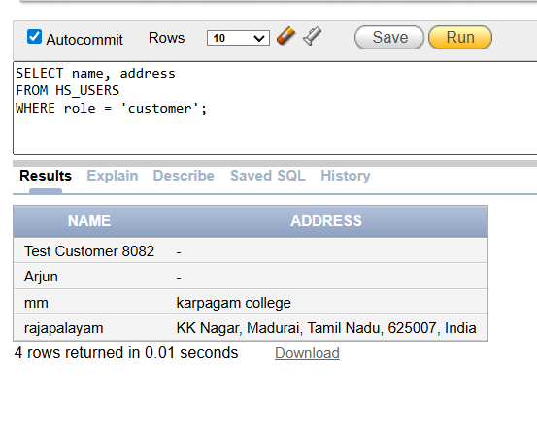
3. View customers with location and pincode
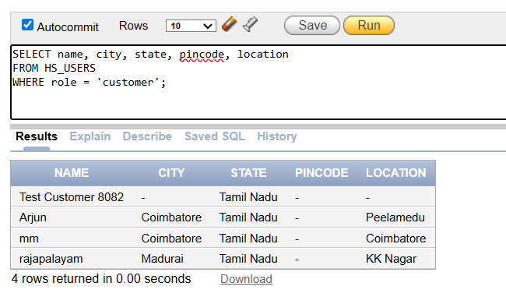
4. View all providers

5. Available Providers Only
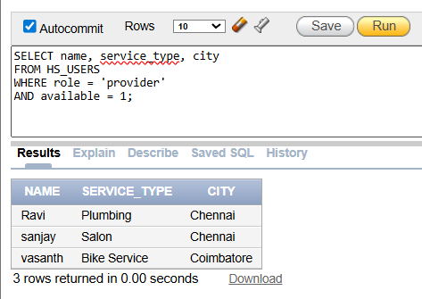
📅 BOOKING SYSTEM QUERIES
6. Provider Job List
7. Completed Bookings
8. Pending Payments
SELECT *
FROM HS_BOOKINGS
WHERE status = 'Pending_Payment';
🔗 RELATIONSHIP / JOIN QUERIES
9. Customer with Their Bookings
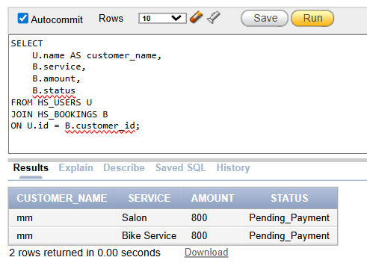
10. Provider with Completed Services
📊 ANALYTICS QUERIES
11. Total Revenue
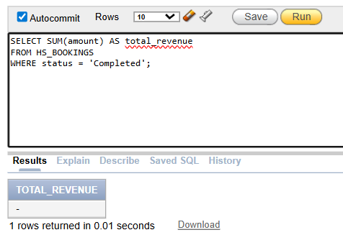
12. Monthly Revenue
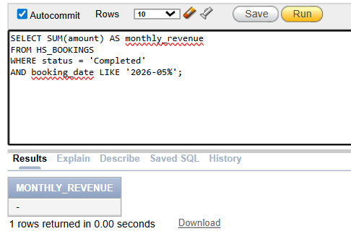
13. Most Demanded Services
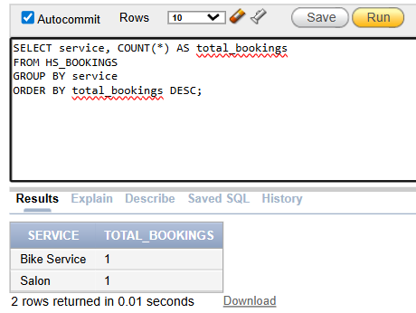
14. Booking Status Distribution
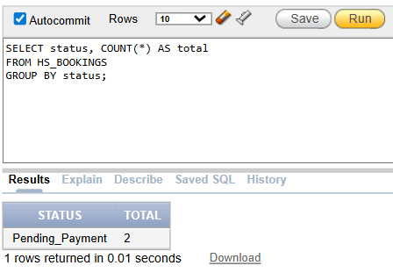
15. Top Earning Providers

🛌 LEAVE MANAGEMENT QUERIES
16. Pending Leave Requests

17. Leave Conflict Detection
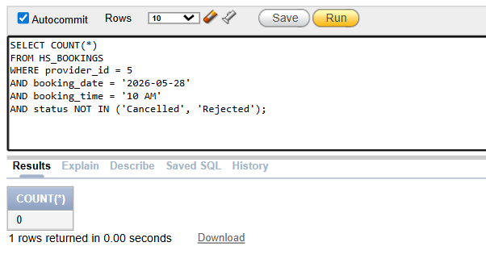
Show Booking Data in Oracle
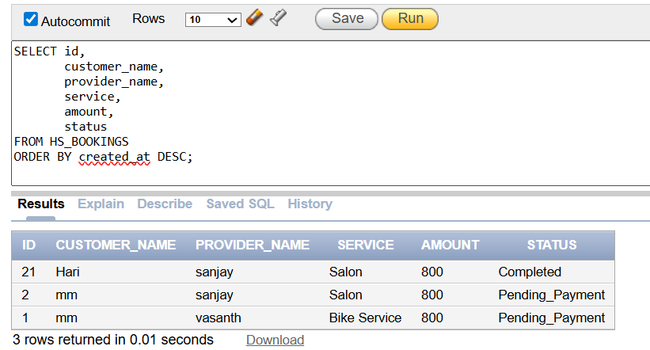
SELECT
ID, NAME, MAIL , ROLE, VERIFIED, AADHAAR_NUMBER
FROM HS_USERS
WHERE ROLE = 'provider';
